EXPERIMENT NO. 09
FLOWCHART TO FIND THE LENGTH OF A STRING USING RAPTOR
AIM
To draw and execute a flowchart in RAPTOR that reads a string from the user, calculates the total number of characters in the string and displays it.
SOFTWARE / TOOLS REQUIRED
- RAPTOR (Rapid Algorithmic Prototyping Tool for Ordered Reasoning)
- Windows PC
PROCEDURE
Step 1: Launch RAPTOR and Create a New Flowchart
- Open the RAPTOR application from the desktop or Start menu.
- Select File → New to create a new flowchart.
- A blank workspace with Start and End symbols will be displayed.
Step 2: Accept the String from the User
- Drag an Input symbol between the Start and End symbols.
- Enter a prompt such as "Enter a String:".
- Store the input in a string variable named str.
Step 3: Calculate the Number of Characters
- Drag an Assignment symbol below the Input symbol.
- Create an integer variable named length.
- Assign the length of the entered string using the string length function.
- Example:
length ← Length_Of(str)

Step 4: Display the Character Count
- Drag an Output symbol below the Assignment symbol.
- Display the message "Total Number of Characters =" along with the value stored in the length variable.
Step 5: Connect and Validate the Flowchart
- Connect the symbols in the sequence Start → Input → Assignment → Output → End.
- Check that all symbols are connected properly and the flowchart logic is correct.
Step 6: Execute the Flowchart
- Click the Run button to execute the flowchart.
- Enter a sample string when prompted.
- Verify that the output displays the correct total number of characters in the entered string.

OUTPUT
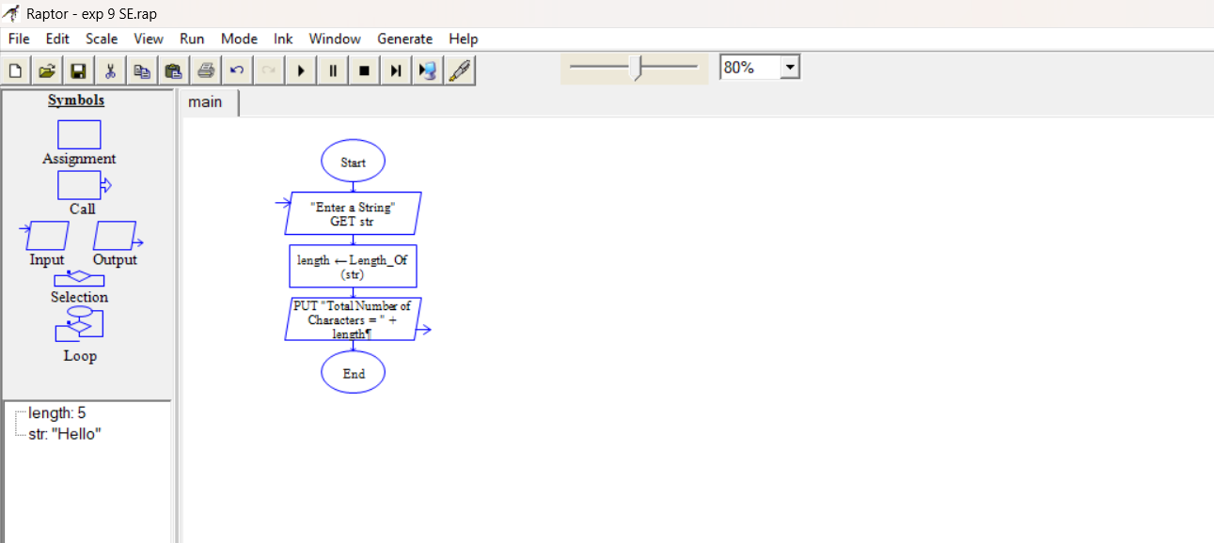

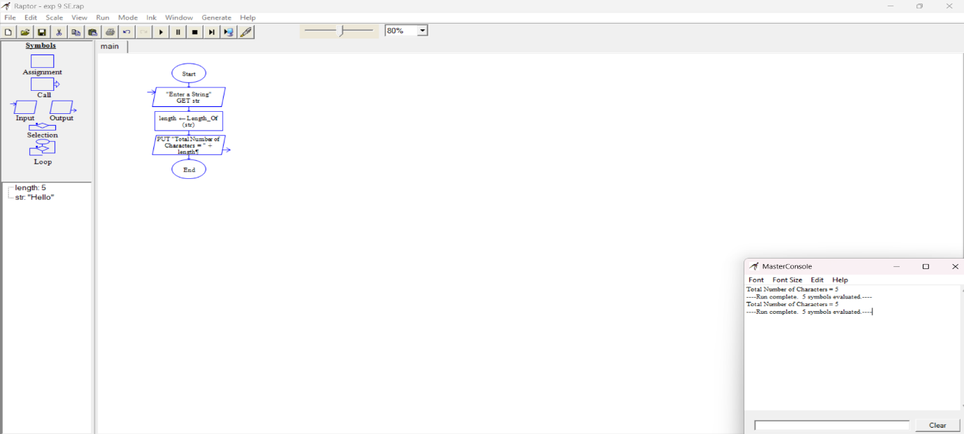

EXPECTED OUTPUT
- Input: Enter a String: Hello
- Output: Total Number of Characters = 5
RESULT
Thus the flowchart to find the length of a given string was drawn, executed and verified using RAPTOR.

